SIDEWALK IMPROVEMENT REIMBURSEMENT PROGRAM
PROGRAM GUIDELINES

Prior to construction, the Highway Superintendent shall inspect the applicant’s sidewalk to determine if it is a public sidewalk and if the improvements conform to the general intention of the sidewalk.
Jeremy Wendt, Highway Superintendent, must be contacted before concrete is poured. His phone number is (315) 730-6863.
Pre-inspection, Pre-Pour Inspection and Final Inspection will be done by the Highway Superintendent or his authorized representative. The Property Owner must contact the Highway Superintendent at (315) 730-6863 to arrange for each inspection of the work.
For work performed by a General Contractor, an estimate for the total cost of concrete including length of sidewalk in feet must accompany the application.
All sidewalk repairs or replacements must be at least four (4) feet in width and, except for the width, must conform to the specifications detailed in the Town’s Development Regulations detailed in the drawing below:
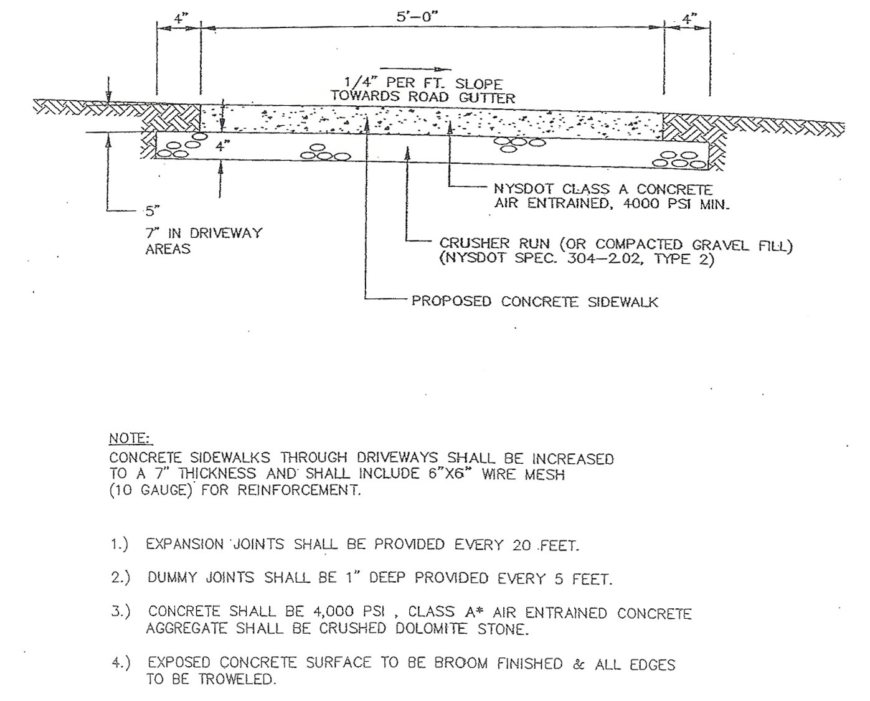

APPLICATION FOR
SIDEWALK IMPROVEMENT REIMBURSEMENT PROGRAM
Date of Application: ____________________
Mailing Address: _____________________________________________ Phone Number: ________________________
I, ____________________________________________________, do hereby request to make sidewalk improvements under the guidelines established by the Town of Seneca Falls at my property located at ____________________________________________________________.

Work to be performed by (check one): General Contractor Self (Property Owner)
By checking this box, I acknowledge receipt of Program Guidelines.
____________________________________________
Applicant’s Signature

IMPORTANT NOTICE
-This application and an estimate of the cost of concrete must be filed in the Town Clerk’s Office PRIOR to beginning work to be certain funds are available.
-The Town will fund projects on a first-come first-serve basis.
-The Town will reimburse the project cost of concrete up to a limit of $800 ($1,600 for corner lots).
-The Town reserves the right to accept or reject any application.
-The Highway Superintendent will calculate the cost based on current concrete prices. Applicant must submit proof (bill from vendor) of cost per yard.
Failure to comply with Program Guidelines will result in application being denied.
For Town Use Only:
 | Pre-work | Initials: |  | __________ |  | Date: | ___________________
 | Pre-pour | Initials: |  | __________ |  | Date: | ___________________
 | Final | Initials: |  | __________ |  | Date: | ___________________
Sidewalk Length & Width |  |  | _____________ |  | Yards of Concrete |  |  | ___________ | Concrete Cost | _________
Total Reimbursement Allowed: _____________
Comments: _______________________________________________________________________________________
_________________________________________________________________________________________________

SIDEWALK COMPLETION VERIFICATION
(To be completed by Contractor)

Date: ____________________________Property Address: ____________________________________

I, __________________________________, as contractor for the project covered under
(PRINT NAME)
the Town of Seneca Falls concrete/paving permit # ___________, do hereby certify that the Town of Seneca Falls specifications for sidewalk replacement were followed in their entirety and further certify that the work was performed and billed according to the quotation provided and attached to the Sidewalk Improvement Reimbursement Program application submitted to the Town of Seneca Falls.

CONTRACTOR SIGNATURE: _________________________________
WITNESS: _________________________________

